HR Analytics Dashboard
Power BI Project Documentation
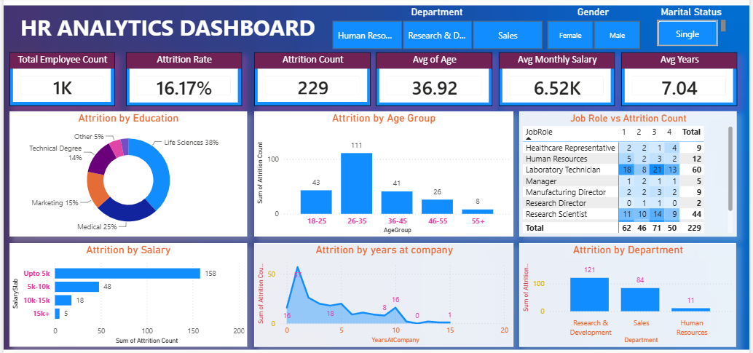
Figure 1: HR Analytics Dashboard

1. Project Overview
This project is an interactive HR Analytics Dashboard built using Power BI. It analyzes employee attrition and workforce trends across age groups, education fields, salary slabs, job roles, job satisfaction levels, years at company, and departments. The dashboard uses KPI cards, charts, a matrix, and interactive slicers to provide an overview of employee attrition.

2. Business Problem
Employee attrition is an important HR metric. The objective of this project is to understand employee turnover patterns and compare attrition across different employee and organizational dimensions.
Key business questions:
- What is the total employee count?
- What is the attrition rate and attrition count?
- Which age groups have higher attrition?
- How does attrition vary by salary slab?
- How does attrition vary across education fields?
- Which departments have higher employee exits?
- How is job satisfaction distributed across job roles?
- How does attrition vary with years at company?

3. Dataset
Source: Kaggle HR Analytics Dataset
https://www.kaggle.com/api/v1/datasets/download/saadharoon27/hr-analytics-dataset
Important fields used include:
- Employee Number
- Age
- Gender
- Department
- Education Field
- Job Role
- Job Satisfaction
- Monthly Income
- Years at Company
- Attrition

4. Tools and Technologies
- Power BI – dashboard and visualization
- Power Query – data cleaning and transformation
- DAX – KPI and analytical measures
- Excel – source dataset

5. Data Preparation
The data was prepared in Power BI using Power Query. Main preparation activities included:
- Checked data types
- Checked missing/null values
- Checked duplicate records
- Validated numerical and categorical fields
- Renamed fields where required
- Created Age Group and Salary Slab categories
- Validated the Attrition field
- Prepared the dataset for visualization

6. KPI Measures

6.1 Total Employees
Total Employees =
DISTINCTCOUNT('HR Data'[EmployeeNumber])

6.2 Attrition Count
Attrition Count = CALCULATE([Total Employees], 'HR Data'[Attrition] = "Yes")

6.3 Attrition Rate
Attrition Rate = DIVIDE([Attrition Count], [Total Employees], 0)
The Attrition Rate measure is formatted as a percentage.

6.4 Average Age
Average Age = AVERAGE('HR Data'[Age])

6.5 Average Monthly Salary
Average Monthly Salary = AVERAGE('HR Data'[MonthlyIncome])

6.6 Average Years at Company
Average Years = AVERAGE('HR Data'[YearsAtCompany])
KPI values are dynamic and change when slicers are applied.

7. Calculated Columns

7.1 Age Group
Age Group =
SWITCH(
TRUE(),
'HR Data'[Age] < 25, "18-24",
'HR Data'[Age] < 35, "25-34",
'HR Data'[Age] < 45, "35-44",
'HR Data'[Age] < 55, "45-54",
"55+"
)

7.2 Salary Slab
Salary Slab =
SWITCH(
TRUE(),
'HR Data'[MonthlyIncome] < 5000, "Up to 5K",
'HR Data'[MonthlyIncome] < 10000, "5K-10K",
'HR Data'[MonthlyIncome] < 15000, "10K-15K",
"15K+"
)

8. Dashboard Visualizations
KPI Cards: Total Employee Count, Attrition Rate, Attrition Count, Average Age, Average Monthly Salary, and Average Years.
Attrition by Education: Donut chart showing attrition distribution across education fields.
Attrition by Age Group: Clustered column chart showing attrition across age groups.
Attrition by Salary: Horizontal bar chart showing attrition across salary slabs.
Job Role vs Job Satisfaction Level: Matrix comparing job roles with job satisfaction levels.
Attrition by Years at Company: Line chart showing attrition count across years at company.
Attrition by Department: Column chart comparing employee attrition across departments.

9. Interactive Slicers
- Gender
- Department
- Marital Status
The Marital Status slicer is an additional filter included in the final dashboard. All KPI cards and visuals respond to the selected filter context.

10. Dashboard Design
- Bold dashboard title
- KPI cards positioned at the top
- Consistent fonts and formatting
- Data labels where useful
- Aligned visuals
- Clear spacing and borders
- Interactive slicers
- Consistent visual styling

11. Key Analysis Areas
- Overall employee attrition
- Age-wise attrition
- Salary-wise attrition
- Department-wise employee exits
- Education-wise attrition
- Job role and satisfaction patterns
- Attrition by years at company
- Filtered attrition by gender, department, and marital status

12. Project Structure
HR-Analytics-PowerBI-Dashboard/
│
├── README.md
├── Dashboard/
│ └── HR_Analytics_Dashboard.pbix
├── Screenshots/
│ └── HR_Analytics_Dashboard.png
└── Documentation/
├── Project_Documentation.docx
└── Project_Documentation.pdf
The source dataset is referenced through Kaggle rather than unnecessarily duplicating the dataset in the repository.

13. Project Outcome
This project demonstrates practical skills in:
- Power BI
- Power Query
- DAX
- Data Cleaning
- KPI Development
- Data Visualization
- Dashboard Design
- HR Analytics
- Business Analysis
- Interactive Reporting
The completed dashboard provides an interactive view of employee attrition and workforce trends and can be used as a portfolio project for Data Analyst roles.

Author
Santosh Kumar
Data Analytics Portfolio Project
Skills: Power BI | SQL | Excel | Python | DAX

